**STEPS TO PERFORM HTTP TRIGGER FUNCTION**

1.Install the required version of python that suited for Azure functions i.e

Python3.6, python3.7 , python 3.8, python 3.9

2. Before you install and run the [Azure Functions extension](https://marketplace.visualstudio.com/items?itemName=ms-azuretools.vscode-azurefunctions), you must meet these requirements:

* [Visual Studio Code](https://code.visualstudio.com/) installed on one of the [supported platforms](https://code.visualstudio.com/docs/supporting/requirements#_platforms).
* An active Azure subscription

## 3. Install the Azure Functions extension:

1. In Visual Studio Code, open **Extensions** and search for **azure functions,** or select this link in Visual Studio Code.

2. Select **Install** to install the extension for Visual Studio Code:

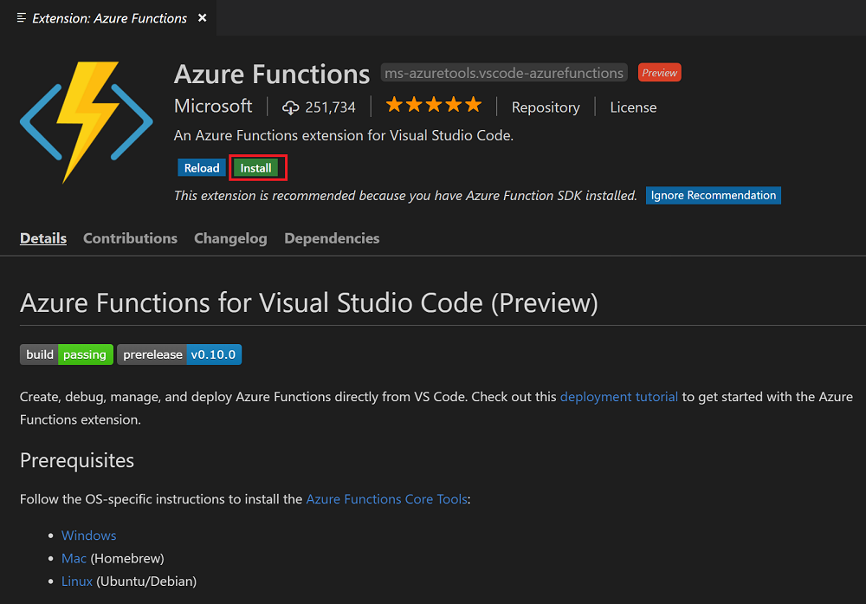

3. After installation, select the Azure icon on the Activity bar. You should see an Azure Functions area in the Side Bar.

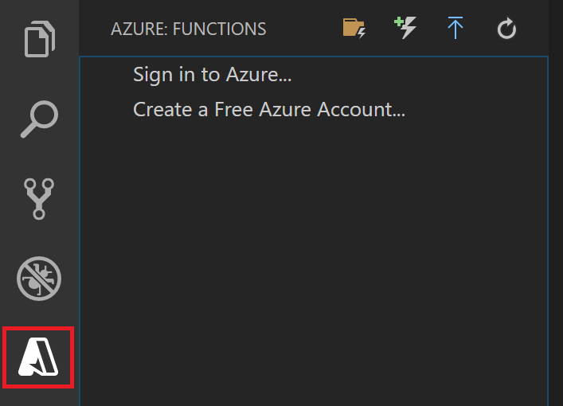

## 4. Create an Azure Functions project

## 1. From **Azure: Functions**, select the **Create Function** icon:

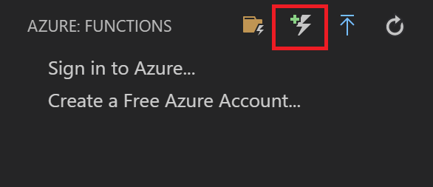

2. Select the folder for your function app project, and then **Select a”Python” for your function project.**

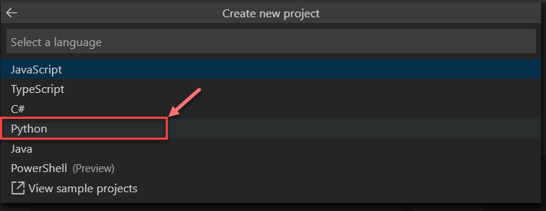

3. Select the **HTTP trigger** function template .

4. Type **Http Example** for the function name and select Enter, and then select function authorization.

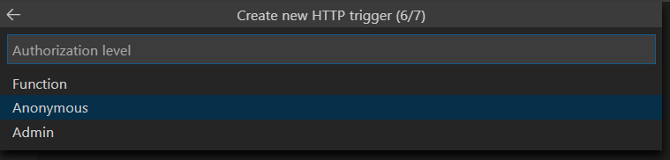

5. A function is created in your chosen language and Once the app is created, you can see something like this on your screen.

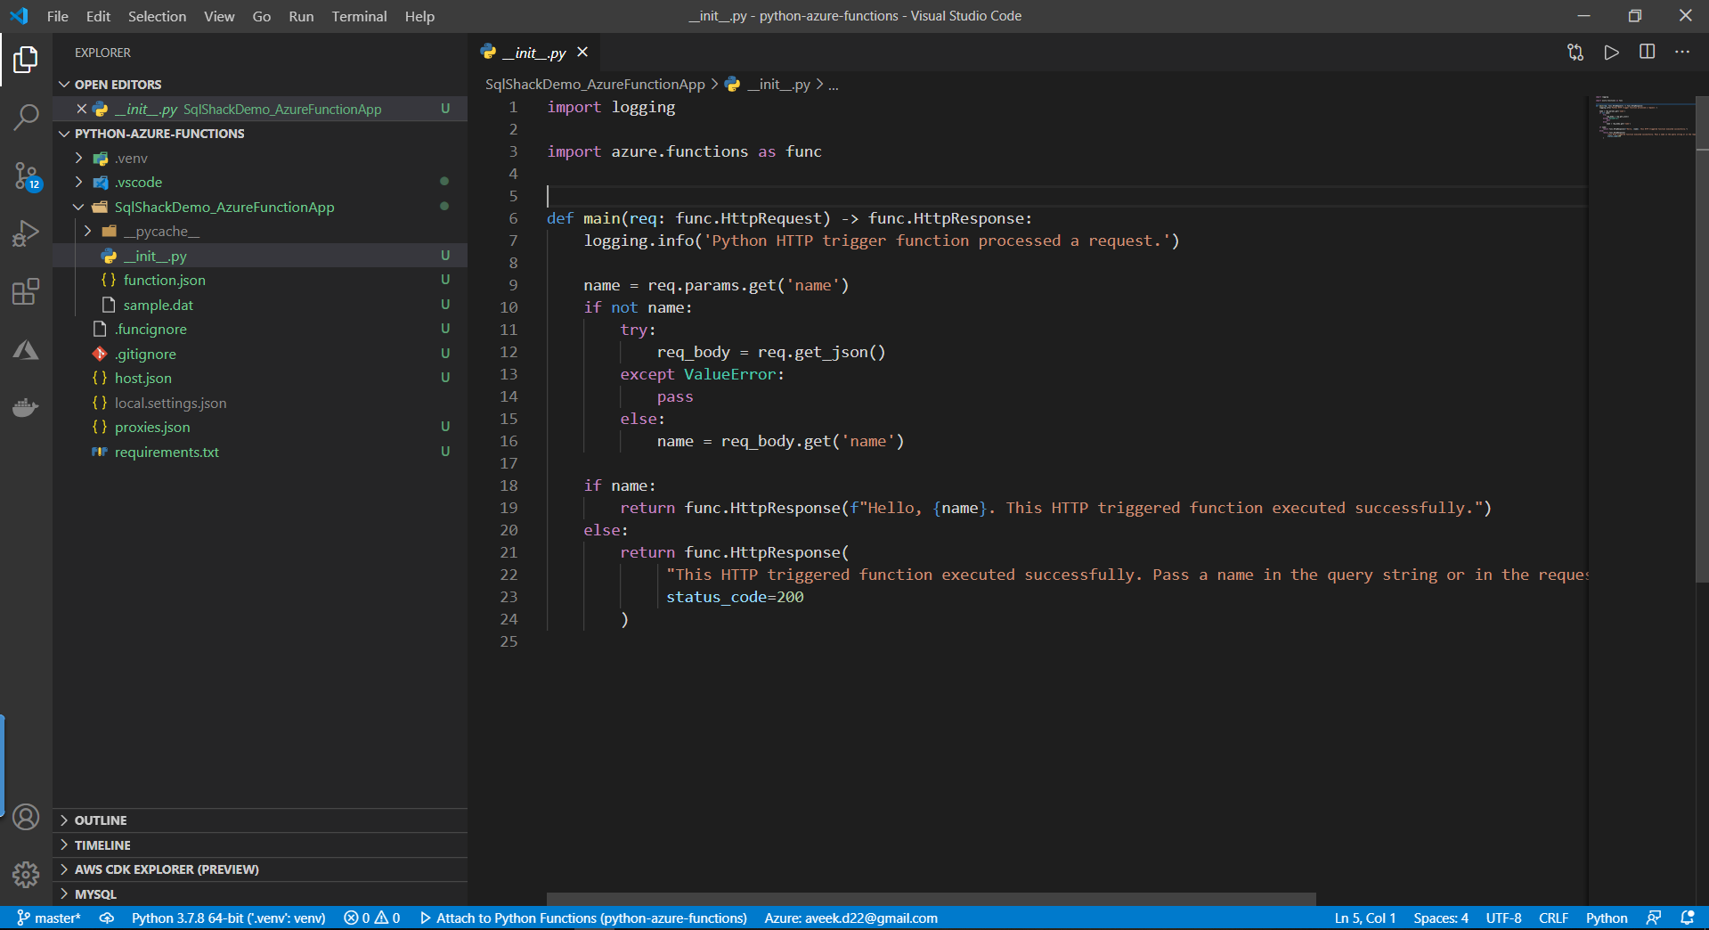

6. The main project folder (<project_root>) can contain the following main files:

**local.settings.json**: Used to store app settings and connection strings when running locally. This file doesn't get published to Azure.

**requirements.txt:** Contains the list of Python packages the system installs when publishing to Azure.

**host.json*:*** Contains configuration options that affect all functions in a function app instance. This file does get published to Azure. Not all options are supported when running locally.

5. Deploying the function to Azure

* To deploy your code to the Function App, click on the Deploy icon, as shown in the figure below.

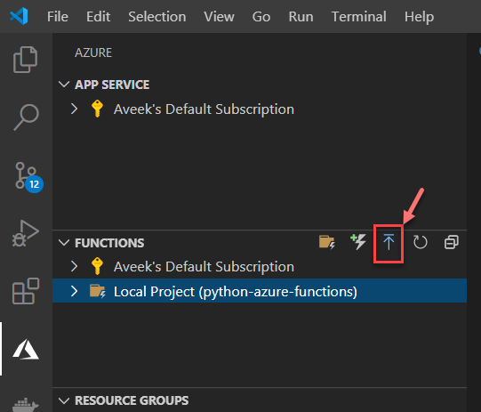

* You will be prompted with the following two options.

